**FOAM RUBBER AIR FILTER PREPARATION – FILTERFLOW EVO**

1. Oil the foam with filter oil, preferably spray, there are many brands, I use this one from Amazon:

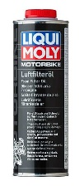

Follow the instructions indicated by the oil manufacturer. I add a splash of oil distributed throughout the foam, put it in a bag and massage it (I squeeze and fold without harshness) so that the oil is distributed. Then I take it out of the bag and let it dry for 5 minutes (that oil comes with a solvent to make it more liquid and you have to let it evaporate).

1. Place the foam inside, it fits just right. Try not to leave any wrinkles. Foam rubber has two densities, it can be seen visually. The less dense side has to be facing the outside.

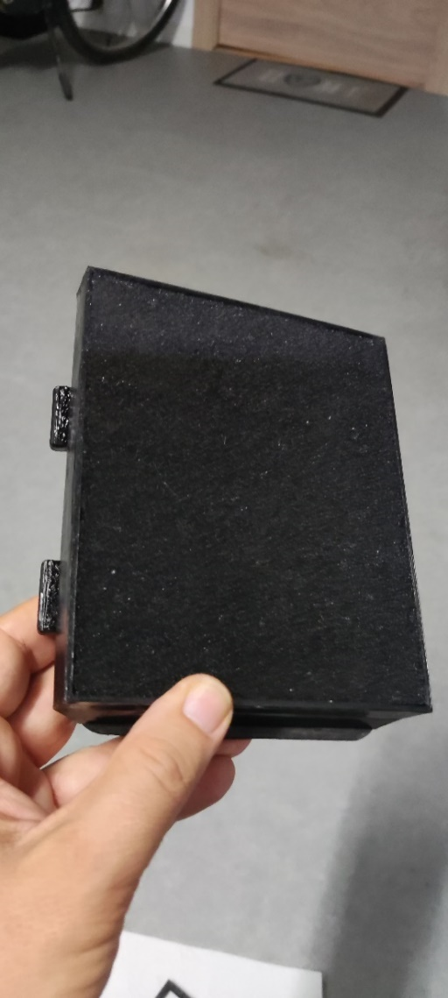

1. 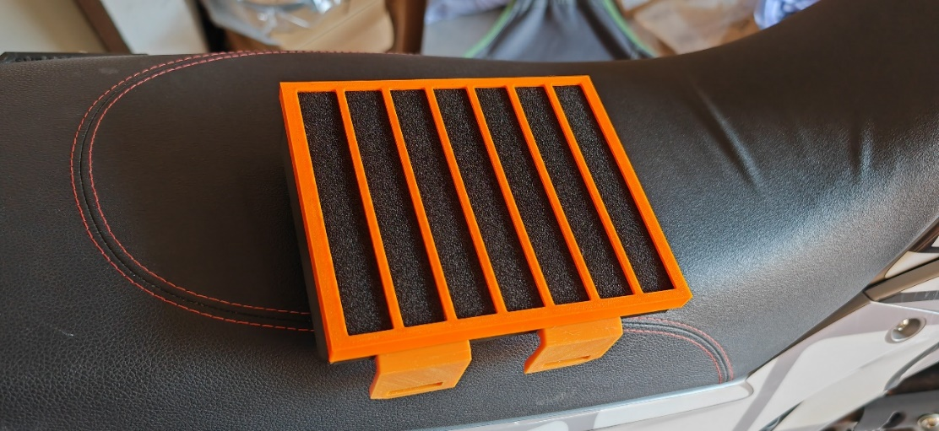Place the exterior grille, which prevents the foam from coming out. First fit the two lower parts and then one upper corner and then the other. It is just right so that it is well secured.
2. Next cut the three interior projections of the filter box cover, as they collide with the largest dimensions of the new filter. You can use cutting pliers.

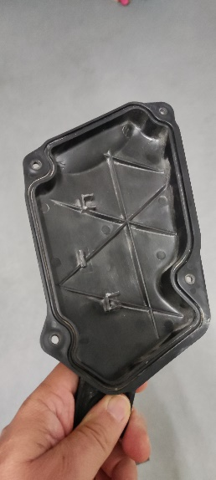

1. Place the filter into the filter box, making sure it fits properly. It is placed the same as the original. You can put grease on the foam gasket, but it is not necessary. It must be well secured and without looseness.

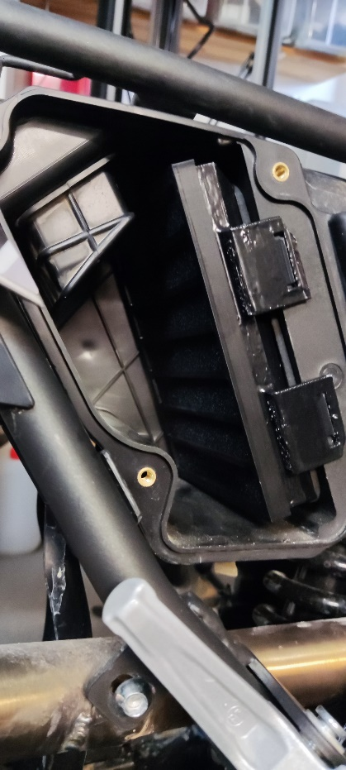

Make sure they fit